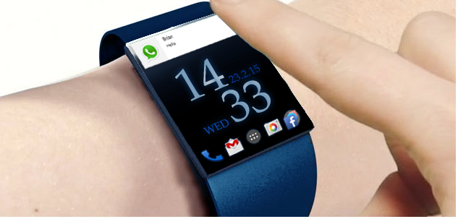

Regulatory Approval

Pretest

監管批准預檢服務

電子產品性能

Electronic Device

Performance

Regulatory Compliance

Consultancy

法規認證顧問服務

**Testing Service for SmartWatch**

**智能手表測試服務**

Evaluate the performance of your product and component with a full set of testing equipment

擁有一套齊全的測試儀器, 助您測試智能手表製品及部件性能

|  |  |
| --- | --- |
| **Electronic Device Performance 電子產品性能測試服務** | |
| **Power Consumption** | **耗電量評估** |
| **RF Communication Range** | **射頻通訊距離** |
| **Production Testing Design** | **生產測試設計** |
| **Electronic Reliability Test** | **電子產品可靠性測試** |
| **Inspection Consultancy** | **驗貨顧問服務** |
| **Regulatory Approval Pretest 法規認證預檢服務** | |
| **CE/FCC Pretests For Following Devices 針對下列產品的CE/FCC預檢：** | |
| **Bluetooth/NFC** | **藍牙／NFC 產品** |
| **Zigbee/Z-Wave** | **Zigbee／Z-Wave 產品** |
| **Wi-Fi** | **無線局域網產品** |
| **Other Electronic Devices** | **其他電子產品** |
| **Regulatory Compliance Consultancy 法規認證顧問服務** | |
| **For further information, please contact:**  Tel**電話**: +852 2788 6396  Fax**傳真**: +852 2788 5405  E-mail**電郵**: [emc@hkpc.org](mailto:emc@hkpc.org)  URL**網頁**: www.hkpc.org  **查詢服務詳情，請聯絡**  **EMC Centre, Hong Kong Productivity Council香港生產力促進局電磁兼容科技中心**  **HKPC Building, 78 Tat Chee Avenue, Kowloon Tong, Kowloon, Hong Kong香港九龍塘達之路78號生產力大樓** | |



www.LabTestOne.org

|  |
| --- |
| **Testing Equipment for SmartWatch 智能手表測試設備**  **- Power Consumption 耗電量評估**  **- RF Communication Range 射頻通訊距離**  **- Production Testing Design 生產測試設計**  **- Electronic Reliability Test 電子產品可靠性測試**  **- Inspection Consultancy 驗貨顧問服務**  **Regulatory Approval Pretest 法定認證預檢服務**  **- CE/FCC Pretests for following devices 針對下列產品的CE/FCC預檢：**  **o Bluetooth/NFC 藍牙／NFC 產品**  **o Zigbee/Z-Wave Zigbee／Z-Wave 產品**  **o Wi-Fi 無線局域網產品**  **o Other electronic devices 其它電子產品**  **Regulatory Compliance Consultancy 法定認證顧問服務** |

Hong Kong Productivity Council offers a full set of advanced testing equipment and professional support services to help you evaluate the performance of your products and components for improving reliability, shortening product development cycle and boosting your competitiveness.

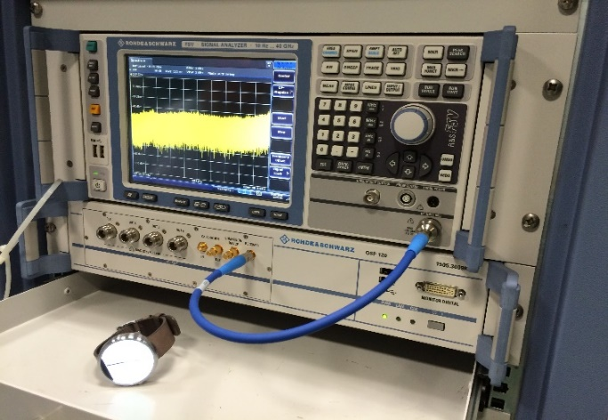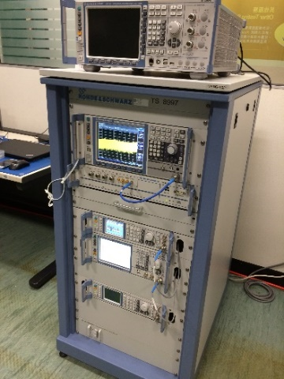生產力局擁有先進的檢測設備和專業支援服務，助您測試智能手表製品及部件性能，以提高產品的可靠性、縮短產品開發週期和增強企業競爭力。

**Wireless Testing 無線產品測試**

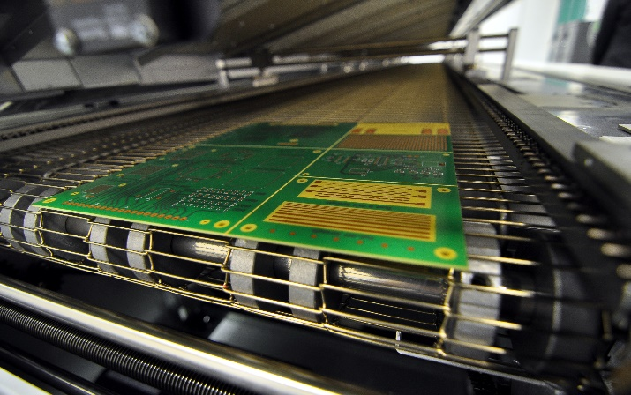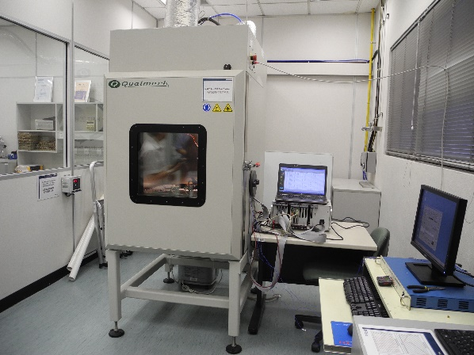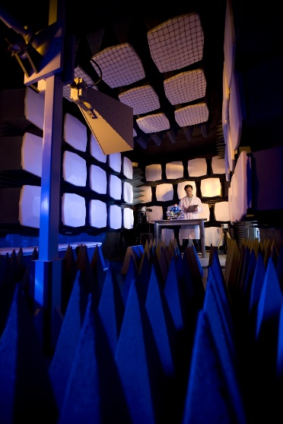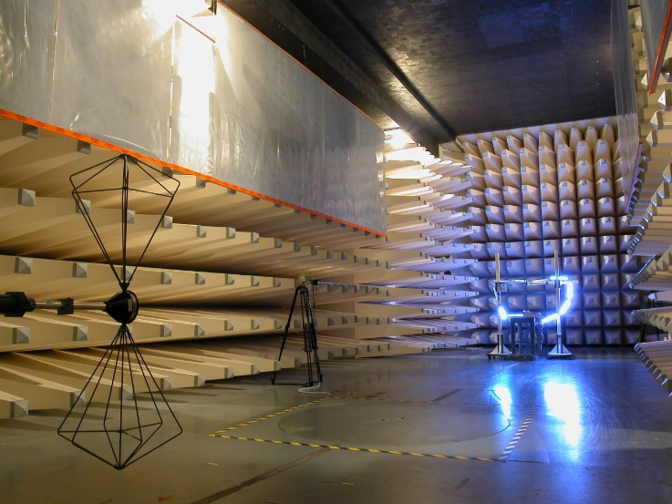

**Reliability Testing 電子產品可靠性測試**

**EMC Testing 電磁兼容測試**

|  |
| --- |
| **For further information, please contact:**  Tel**電話**: +852 2788 6396  Fax**傳真**: +852 2788 5405  E-mail**電郵**: [emc@hkpc.org](mailto:emc@hkpc.org)  URL**網頁**: www.hkpc.org  **查詢服務詳情，請聯絡**  **EMC Centre, Hong Kong Productivity Council香港生產力促進局電磁兼容科技中心**  **HKPC Building, 78 Tat Chee Avenue, Kowloon Tong, Kowloon, Hong Kong香港九龍塘達之路78號生產力大樓** |