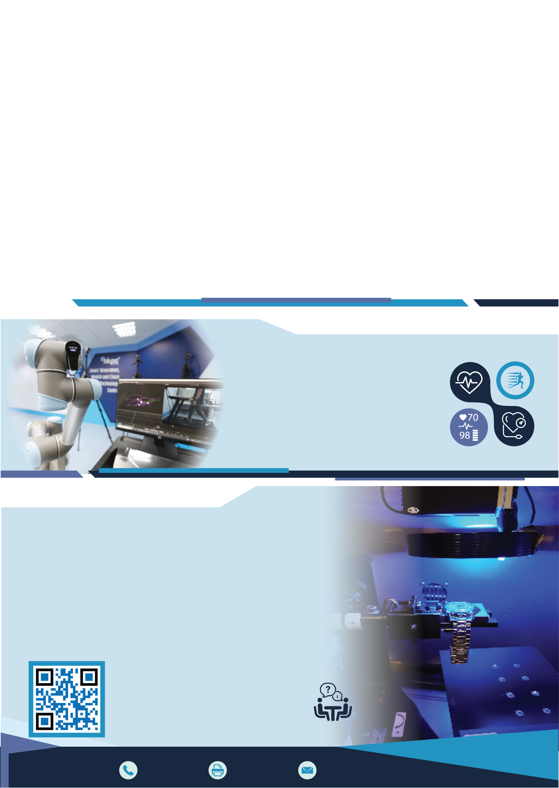


智能穿戴及鐘錶
智能穿戴及鐘錶測試服務
Smart Wearables, Watch & Clock Testing Service

科技中心

Smart Wearables,
Watch & Clock
Technology Centre
為加強本地智能穿戴及鐘錶業在世界市場之競爭力及領導地位，香港生產力促進局
「智能穿戴及鐘錶科技中心」時刻緊貼技術趨勢，並透過一系列全面支援服務，讓本港製造商能掌握最新技術。
中心提供的服務包括根據國際及瑞士鐘錶業標準，為傳統石英錶和機械錶提供超過50項獨立的品質測試及分析服務，另外亦提供智能穿戴的測試與驗證服務，包括計步、心率、血壓和血含氧量的準確性測試等。
To enhance the competitiveness and strengthen the leading position of the local smart wearables, watch and clock industry, the Smart Wearables, Watch and Clock Technology Centre of the Hong Kong Productivity Council stays on top of technology trends and provides a comprehensive range of support services for local manufacturers to help them build awareness and knowledge of the latest technology in the market.
The Centre offers not only over 50 different independent testing services for traditional quartz and mechanical watches in compliance with international & Swiss standards, but also smart wearable testing services, including the performance testing of devices for measuring steps, heart rates, blood pressure and oxygen content in blood, etc.

智能穿戴
Smart Wearables

物聯網安全
IoT Security

無綫電
Wireless
電磁兼容
測試服務 Testing Services

計步
Step-counting

心率
Heart Rate

腕錶 WristWatch
Electromagnetic Compatibility

可靠性
Reliability
血壓
Blood Pressure

血含氧量
Oxygen Content in Blood

測試服務 Testing Services

天文台錶測試 ISO3159

防水測試 ISO22810
ISO22810 Water Resistance Test

防磁測試 ISO764
ISO764 Magnetic Resistance Test

防震測試 ISO1413
ISO1413 Shock Resistance Test

溫度及濕度測試
Temperature & Humidity Test
ISO3159 Chronometer Test

潛水錶測試 ISO6425
ISO6425 Diver’s Watches Test

耐磨性測試 ISO23160
ISO23160 Abrasion Resistance Test

耐刮損測試 ISO23160
ISO23160 Scratch Resistance Test

耐衝擊測試 ISO23160
ISO23160 Impact Resistance Test

如欲了解更多相關測試項目或要求客製化測試，歡迎與我們聯絡。
Please contact us for further details
on testing items or customised services.

智能製造部
Smart Manufacturing Division

聯絡資料
Contact Information
+852 2788 5537
+852 2788 5678
+852 2788 5522 hkpcenq@hkpc.org

