


智能穿戴及钟表
智能穿戴及鐘錶測試服務
Smart Wearables, Watch & Clock Testing Service

科技中心

Smart Wearables,
Watch & Clock
Technology Centre
为加强本地智能穿戴及钟表业在世界市场之竞争力及领导地位，香港生产力促进局「智能穿戴及钟表科技中心」时刻紧贴技术趋势，并透过一系列全面支持服务，让本港制造商能掌握最新技术。
中心提供的服务包括根据国际及瑞士钟表业标准，为传统石英表和机械表提供超过50项独立的品质测试及分析服务，另外亦提供智能穿戴的测试与验证服务，包括计步、心率、血压和血含氧量的准确性测试等。
To enhance the competitiveness and strengthen the leading position of the local smart wearables, watch and clock industry, the Smart Wearables, Watch and Clock Technology Centre of the Hong Kong Productivity Council stays on top of technology trends and provides a comprehensive range of support services for local manufacturers to help them build awareness and knowledge of the latest technology in the market.
The Centre offers not only over 50 different independent testing services for traditional quartz and mechanical watches in compliance with international & Swiss standards, but also smart wearable testing services, including the performance testing of devices for measuring steps, heart rates, blood pressure and oxygen content in blood, etc.

智能穿戴
Smart Wearables

物联网安全
IoT Security

无线电
Wireless
电磁兼容
测试服务 Testing Services

计步
Step-counting

心率
Heart Rate

腕表 WristWatch
Electromagnetic Compatibility

可靠性
Reliability
血压
Blood Pressure

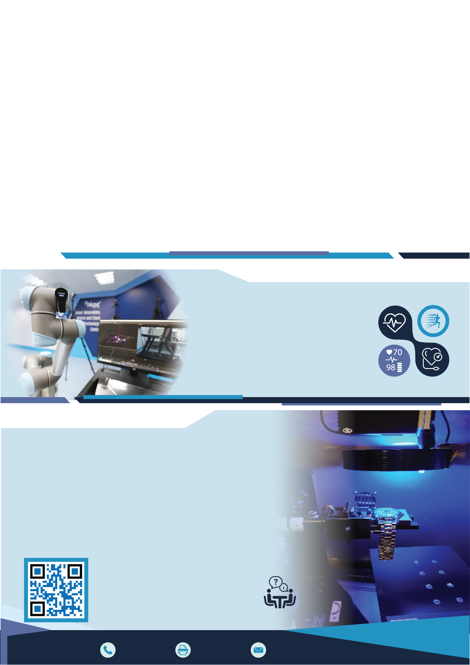
血含氧量
Oxygen Content in Blood

测试服务 Testing Services

天文台表测试 ISO3159

防水测试 ISO22810
ISO22810 Water Resistance Test

防磁测试 ISO764
ISO764 Magnetic Resistance Test

防震测试 ISO1413
ISO1413 Shock Resistance Test

温度及湿度测试
Temperature & Humidity Test
ISO3159 Chronometer Test

潜水表测试 ISO6425
ISO6425 Diver’s Watches Test

耐磨性测试 ISO23160
ISO23160 Abrasion Resistance Test

耐刮损测试 ISO23160
ISO23160 Scratch Resistance Test

耐冲击测试 ISO23160
ISO23160 Impact Resistance Test

如欲了解更多相关测试项目或要求客制化测试，欢迎与我们联络。
Please contact us for further details
on testing items or customised services.

智能制造部
Smart Manufacturing Division

联络资料
Contact Information
+852 2788 5537
+852 2788 5678
+852 2788 5522 hkpcenq@hkpc.org

